**Note**: Before beginning, please *ensure that all new data are downloaded, in the appropriate folders, and cleaned* as outlined in the data download and cleaning documentation.

Power BI Refresh Instructions

1. Open the report
   1. Open the **ncw_dashboard** report in Power BI desktop
2. Refresh the data
   1. Click Refresh. This will update the visuals with the latest cleaned data.

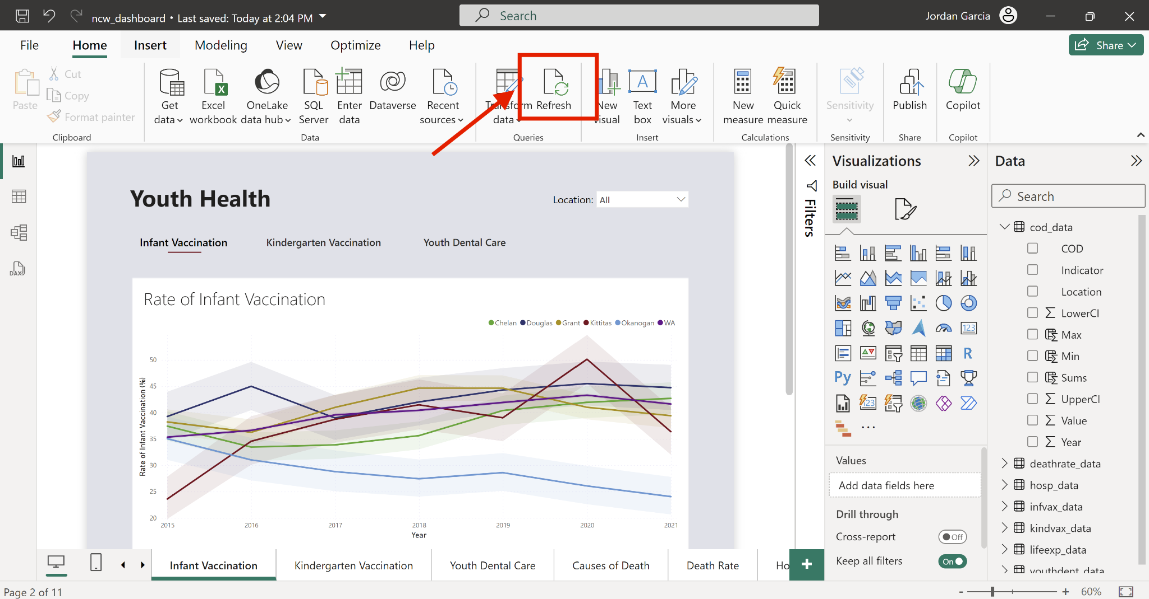

1. Publish the changes.
   1. Click Publish to push the changes to the Power BI service.

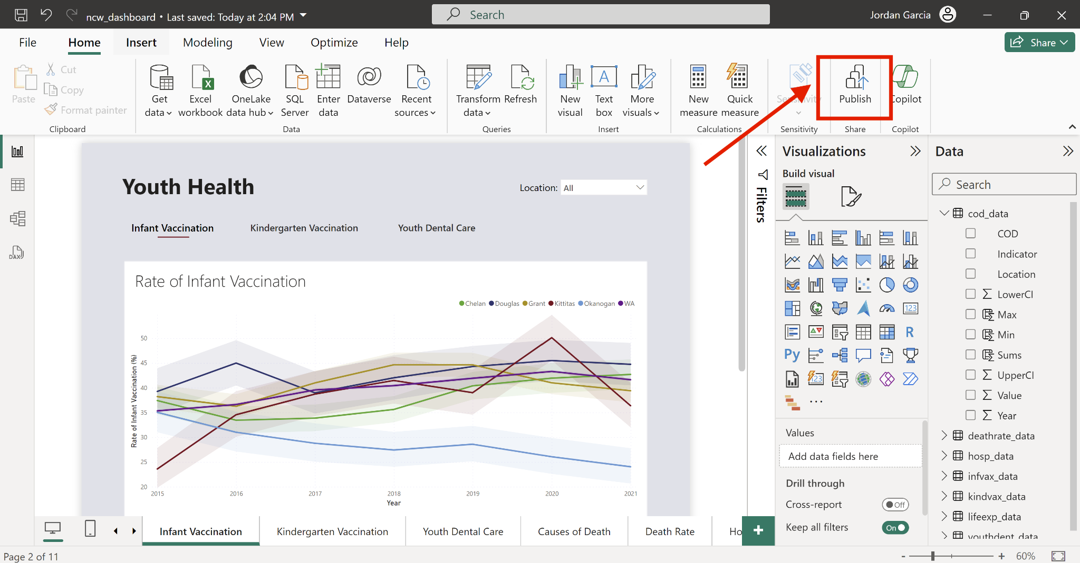

* 1. Save any unsaved changes

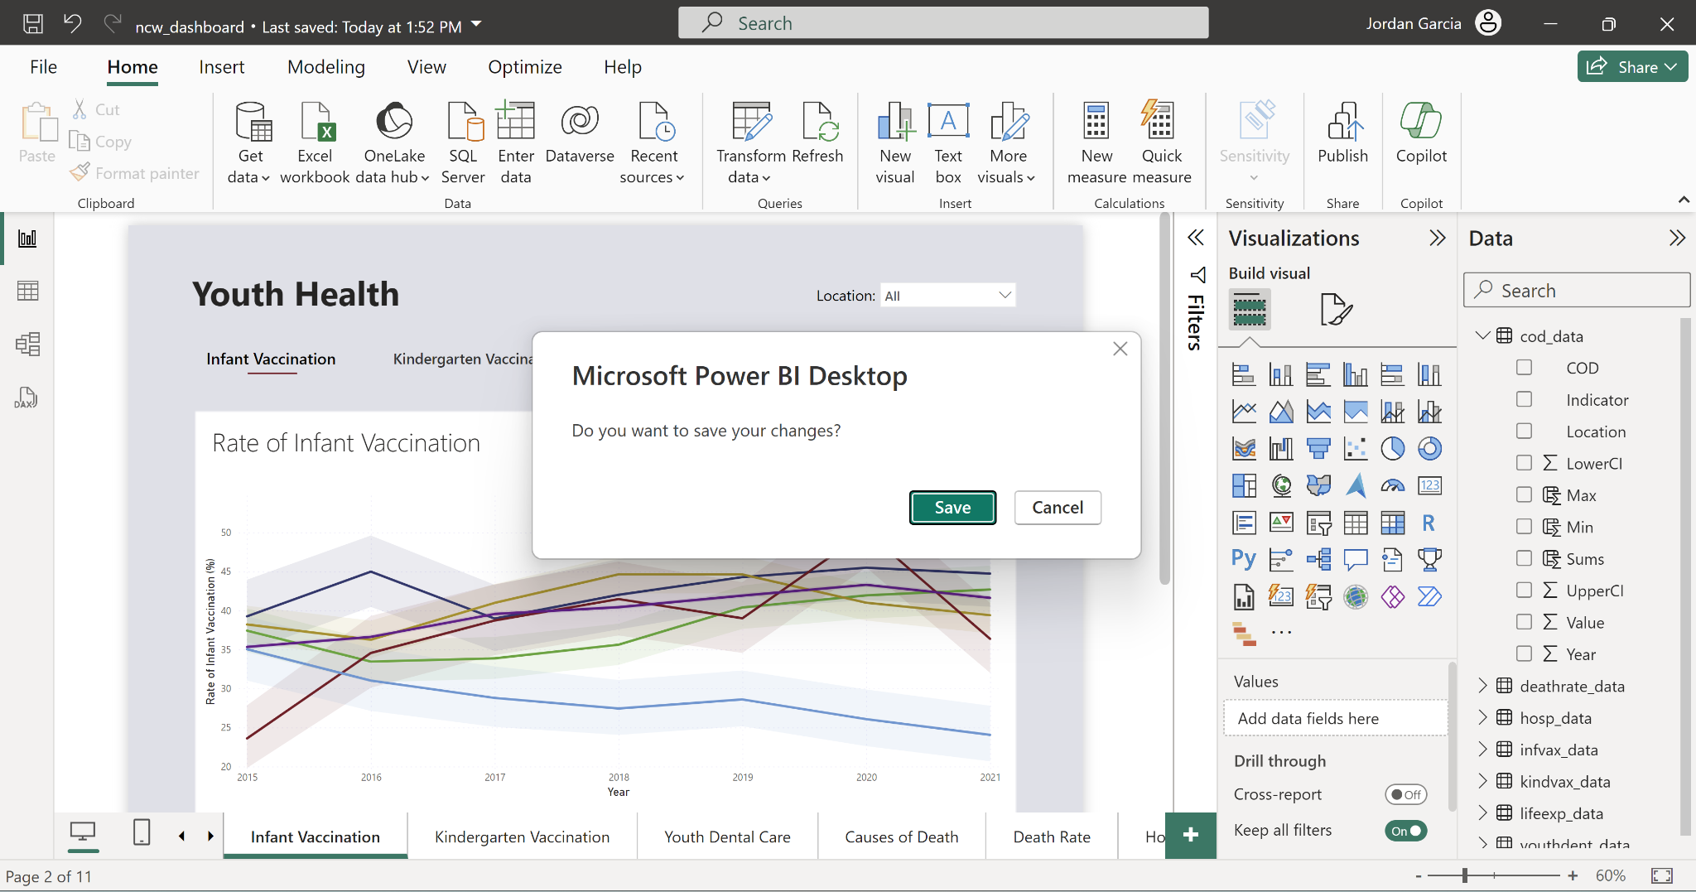

* 1. Select My Workspace

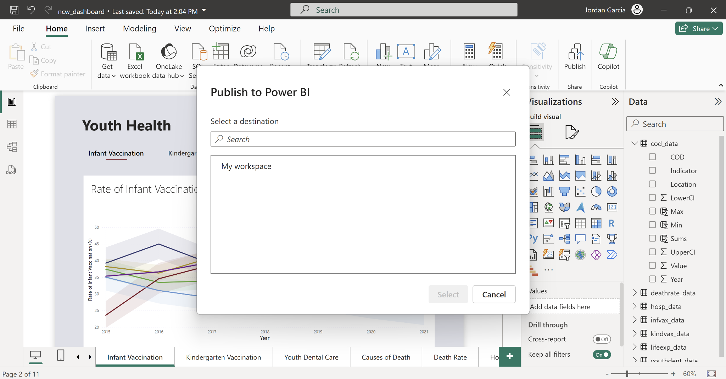

* 1. Click Replace. Note: if it is your first time publishing this dashboard, it will not ask you to replace the dataset.

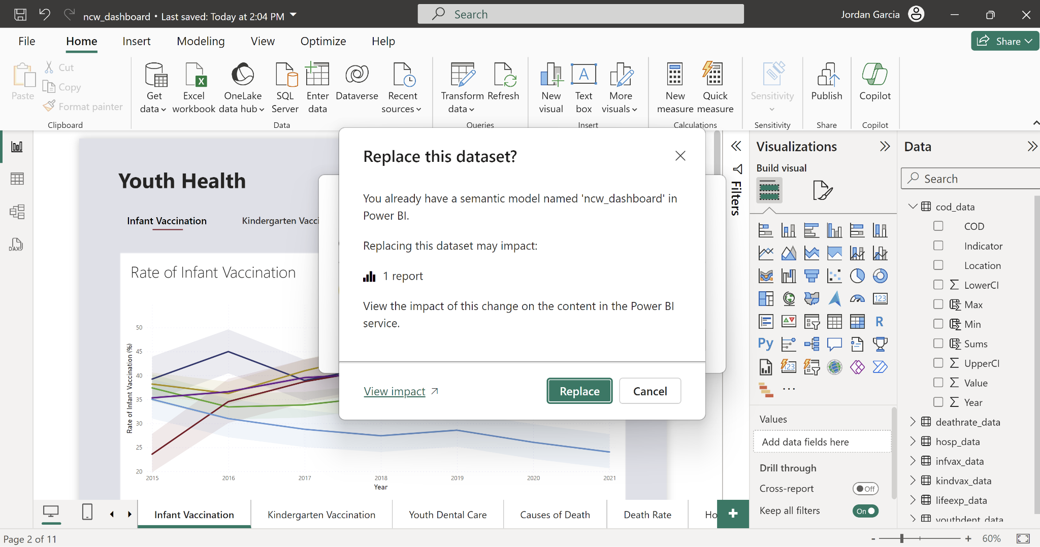

1. Access Power BI service on the web
   1. Clink the link to go to the Power BI service on the web

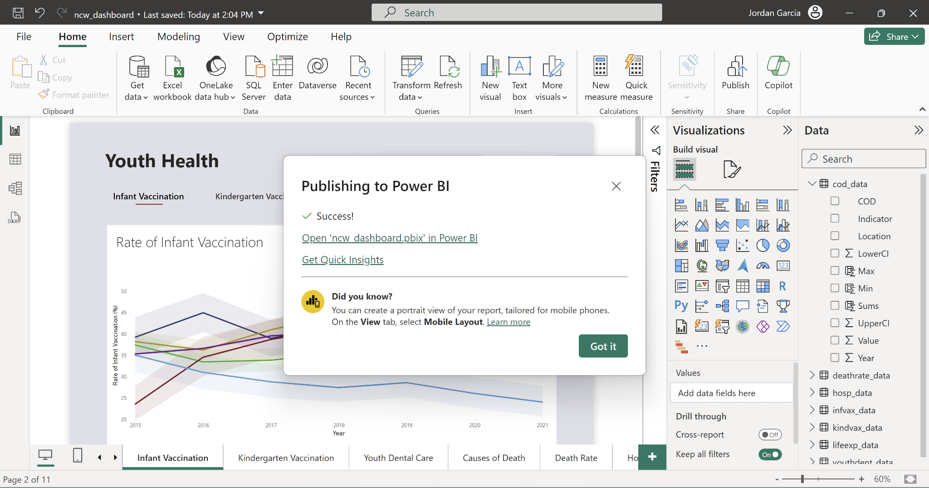

1. Refresh the data in Power BI service on the web
   1. Navigate to My Workspace

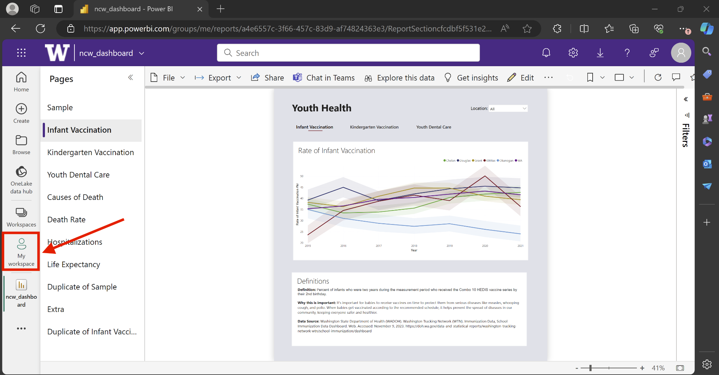

* 1. Click on Lineage View

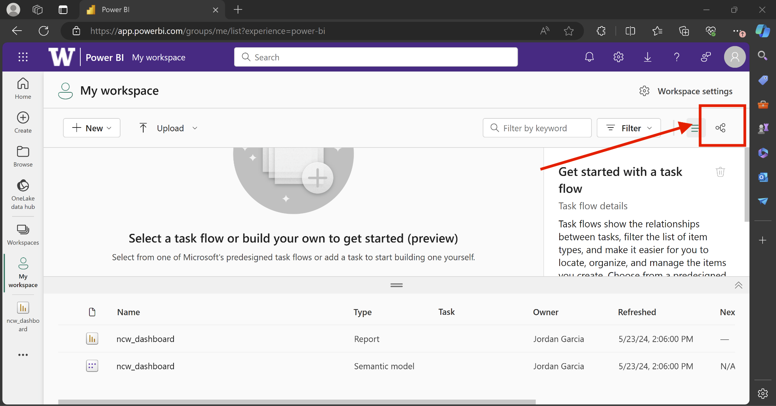

* 1. Scroll to ncw_dashboard Semantic model
  2. Click Refresh Now

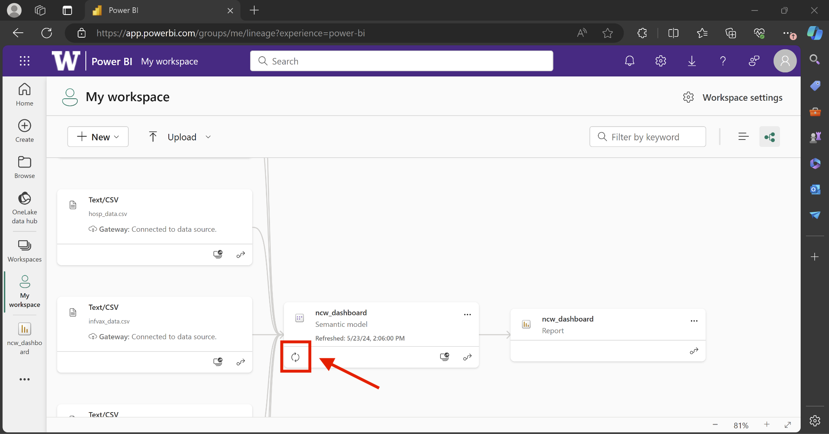

Changes not reflected on the website?

* Clear Browser Cache: Sometimes, browsers cache the old version of the embedded report. Clear your browser's cache or open the WordPress page in an incognito/private browsing window to see if the changes appear.
* Check Power BI Service Status: Verify if there are any ongoing issues or outages with the Power BI Service that might be affecting your reports.